**Unit Test Results**

DB: MySQL

Programming Language: Python, Flask

UI Framework: HTML5

DB Details:

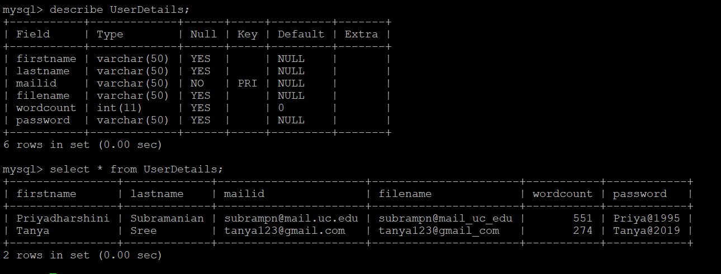

Login Page:

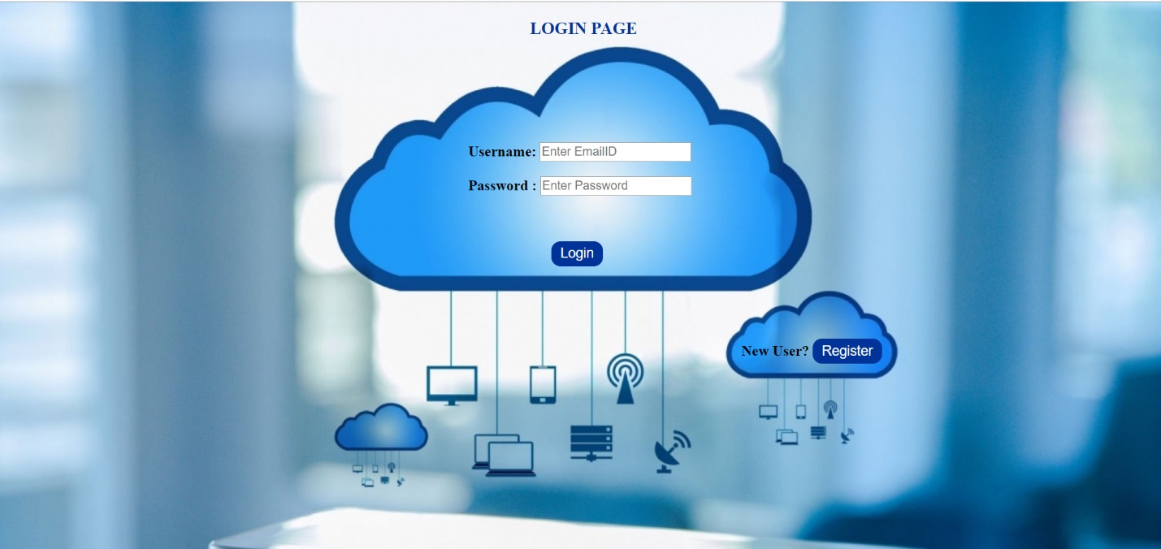

Registration page:

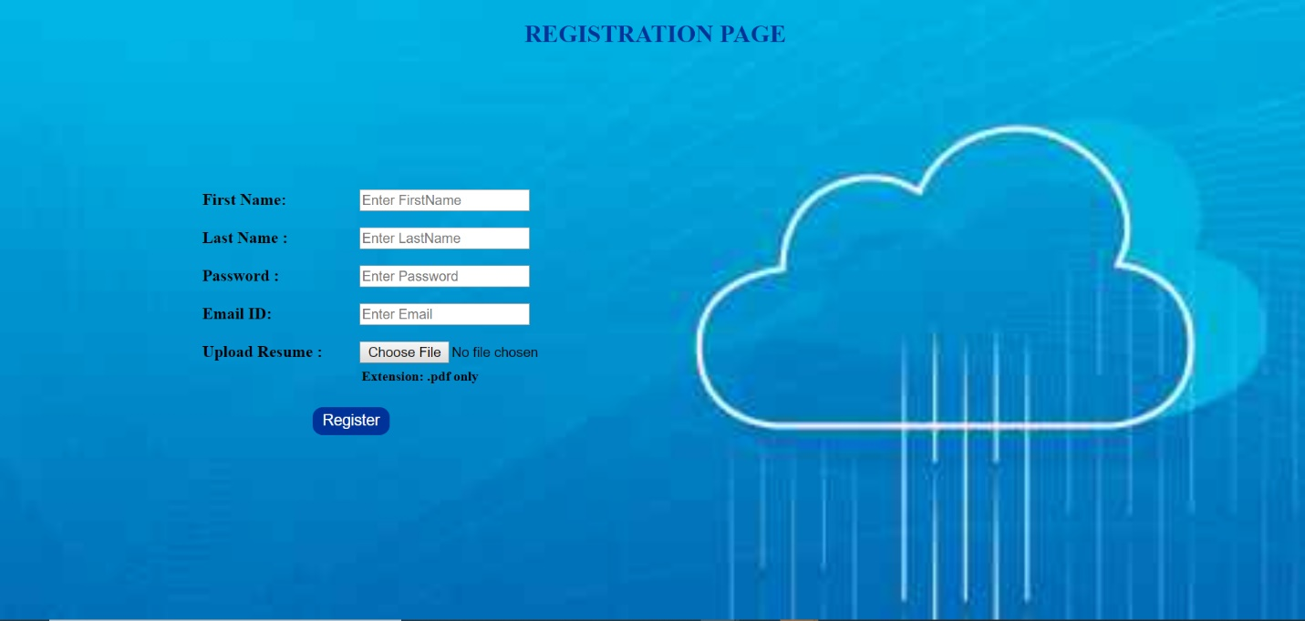

**Step 1: Registration of details and file upload**

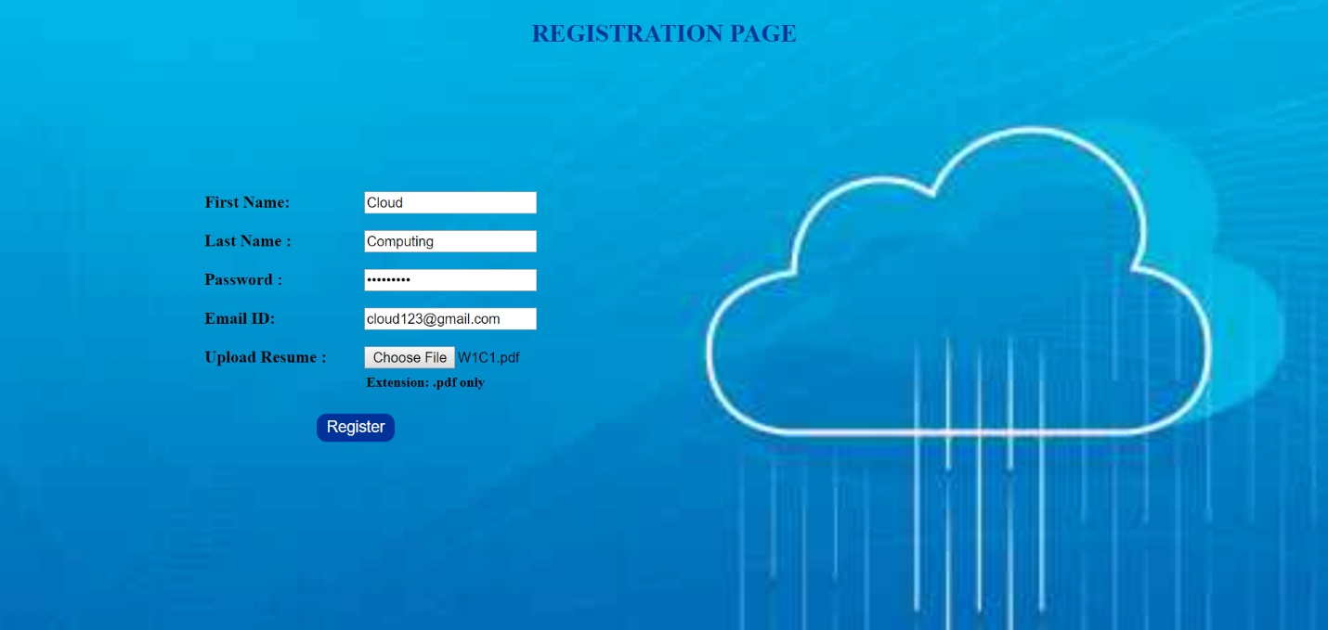

**DB after registration:**

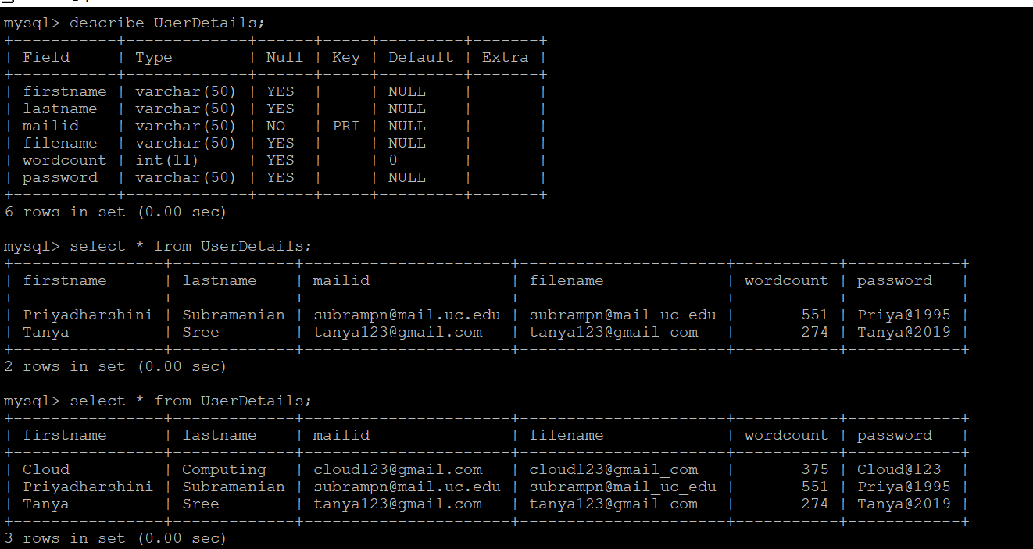

**Step 2: Login**

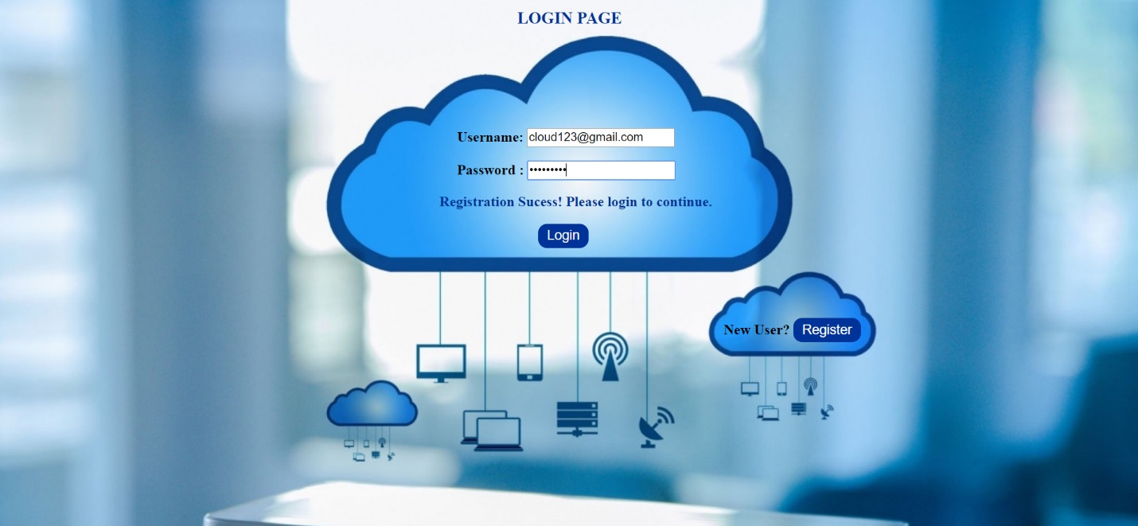

**Step 3: Display of details and file upload**

